

American International University-Bangladesh (AIUB)  
**Department of Computer Science  
Faculty of Science &Technology (FST)  
Spring 21_22**

**Section: I  
Group No: 07**

Final Destination

A software Engineering project submitted

By

|  |  |  |  |  |
| --- | --- | --- | --- | --- |
| S/N | Student Name | Student ID | Contribution (%) | Individual Marks |
| 22 | Shinzon Siddiqua | 20-43671-2 | 20% |  |
| 23 | Ridita Zaman Adikta | 20-43679-2 | 20% |  |
| 25 | Faizur Rahman | 20-43701-2 | 20% |  |
| 26 | Md. Sabit Hasan | 20-43703-2 | 20% |  |
| 27 | Md. Ashraful Islam Emad | 20-43710-2 | 20% |  |

The project will be Evaluated for the following Course Outcomes

|  |  |
| --- | --- |
| Your Project will be Evaluated based on the following marking criteria | Total Marks |
|  |
| Requirements Analysis (functional, quality, and project requirements) [5Marks] |  |
| System Design (UI/UX design) & Test case [5Marks] |  |
| Project Management Planning [5Marks] |  |
| Submission, Completeness, Spelling, Grammar and Organization [5Marks] |  |

Submission Date: 07/08/2022

Description of Student’s Contribution in the Project work

|  |
| --- |
| Student Name: Shinzon Siddiqua  Student ID: 20-43671-2  Contribution in Percentage (%):20%  Contribution in the Project:   * Contribution Description 1,2,3,4   _Shinzon Siddiqua___  Signature of the Student |
| Student Name: Ridita Zaman Adikta  Student ID: 20-43679-2  Contribution in Percentage (%):20%  Contribution in the Project:   * Contribution Description 1,2,3,4   __Ridita Zaman Adikta__  Signature of the Student |
| Student Name: Faizur Rahman  Student ID: 20-43701-2  Contribution in Percentage (%):20%  Contribution in the Project:   * Contribution Description 1,2,3,4   ___ Faizur Rahman ____  Signature of the Student |
| Student Name: Md. Sabit Hasan  Student ID: 20-43703-2  Contribution in Percentage (%):20%  Contribution in the Project:   * Contribution Description 1,2,3,4   __Md. Sabit Hasan____  Signature of the Student |
| Student Name: Md. Ashraful Islam Emad  Student ID: 20-43710-2  Contribution in Percentage (%):20%  Contribution in the Project:   * Contribution Description 1,2,3,4   __ Md. Ashraful Islam Emad __  Signature of the Student |

# PRODUCT AND PROJECT DESCRIPTION

## System Features

* List down the system functional requirements that describes the system’s functionalities

1. **Search:**

**Functional requirement:**

**1.1** The user can search any route or bus in the search box.

**Priority Level:** High

**Precondition:** User need to go through home page to enter the search box.

**Cross-references:**

1. **Route**

**Functional requirement:**

**2.1** User can find all the public buses routes of Dhaka city.

**2.2** When user search a route, it will show the available bus.

**Priority Level:** High

**Precondition:** User need to go through the search box.

**Cross-references:** 1.1

1. **Map**

**Functional requirement:**

**3.1** It will show the traffic situation.

**Priority Level:** High

**Precondition:** User need to go through the home page.

**Cross-references:**

1. **List of Bus:**

**4.1** User can find all the buses of Dhaka city in this list.

**4.2** When user will select a bus and it will show the route of that bus.

**Priority Level:** Medium

**Precondition:** User need to go through home page to enter bus chart.

**Cross-references:**

1. **Place:**

**5.1** User can find any important place which he needs to go**.**

**5.2** If user can’t find any important place then it will show “Not Found”.

**5.3** User can suggest add missing important place.

**Priority level:** Medium

**Precondition:** User need to go through home page.

**Cross-references:**

1. **History:**

**6.1** User can find his/her uses**.**

**6.2** User can recall again form there.

**Priority level:** Medium

**Precondition:** User need to go through home page to enter the history chart.

**Cross-references:** 1.1 , 2.1 , 3.1 , 4.1 , 5.1

1. **General Information:**

**7.1** User can find provided information.

**7.2** User can change or modify information.

**Priority level:** High

**Precondition:** User need to go through home page.

**Cross-references:**

## System Quality Attributes

1. List down the quality attributes that describes how well the system should perform.

* **PERFORMANCE:** The users of this software can expect to log in to the server within 5-10 seconds after they are verified. In performance we can also accept that, there will be enough storage to save all the important data and also the usage loads. And also our application can reload fast in lower kbps speed internet connections. The users of this software can expect to log in to the server within 5 seconds after they are verified. In performance we can also accept that, there will be enough storage to save all the important data and also the usage loads. And also our application can reload fast in lower kbps speed internet connections.
* **EFFICIENCY:** Our application will try to consume less disk space for running the application and also it will take less Ram to run the application efficiently and smoothly. We can expect that the users of our application will face less problem to run this app in lower configuration mobile phones and computer devices.
* **FLEXIBILITY:** Our software is able to adapt to changes in both environment and usability requirements without encompassing structural changes. Our software engineer can add or change feature and help us to find errors easily or run the testes if needed in our software.
* **INTEGRITY:** All the information of the users and also the history will be highly secured.
* **INTEROPERABILITY:** The ability for any mobility technology component to exchange data from our software to with other component like Google Map in that mobility technology system.
* **PORTABILITY:** There will be different platforms like android apps, IOS applications, Web browsers, and the users can access our application.
* **REUSABILITY:** If our software updates to a newer version, we can be able to use the previous versions of codes and functionalities.
* **RELIABILITY:** Our software system will fulfill assigned task in the given environment and all the users can expect a free of error inputs and outputs**.**
* **ROBUSTNESS:** If a user is about to change his information data, but he forgets to save that information, there will be recovery options and all the information will be restored as he edited.
* **MAINTAINABILITY:** In our software our maintenance programmers are available to modify all the functions and the time to resolve problems within a short time.

## Project Requirements

* List down the project constraints (e.g., time, budget, resources, environment, etc.) that should be followed in the project management.
  + - **Time:** We can expect to complete this project within 6 months and we think that it will be enough time to develop this project and run the project efficiently.
    - **Budget:** Our software budget is estimated at half Million taka to build it.
    - **Resource:** For our project, we need some skillful programmers and web developers and some people. Also, we need a Farm-house and it will be well organized. We also need an alternative analyzer, expert judgment, and project estimating.
    - **Environment:** We will develop our projects in Python language, MySQL, VS-Code, Django in our back-end development. And for the front-end we will need HTML, CSS, JAVASCRIPT(REACT), Bootstrap. For hardware devices, we need some good computers to build this app. All the computers will be connected with wi-fi routers and also all the team members can be connected with others.
    - **Tools:** we need pencil tools and adobe illustrator to design our software UI/UX design.

# SYSTEM DESIGN SPECIFICATION

## UI/UX Design

* Design a prototype of your proposed solution (Web/Desktop/Mobile/Device) using the selected tools based on the UI/UX design principles.

**From user view:**

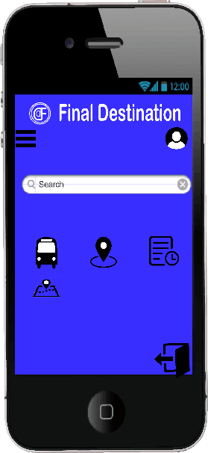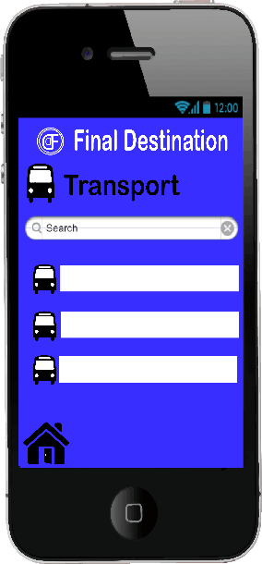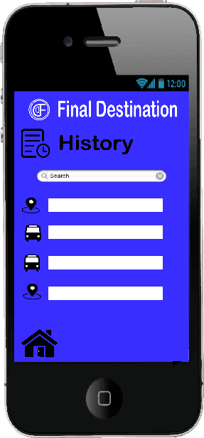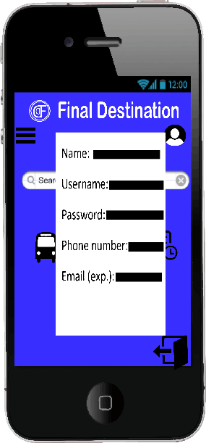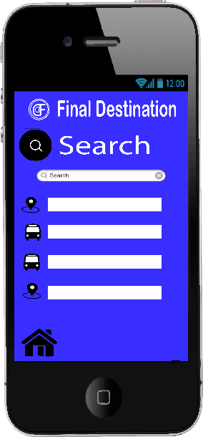

# SYSTEM TEST PLAN

* Select a particular system (Web/Desktop/Mobile/Device) and identify various modules of the system so that they can be tested stand alone.
* Prepare test cases of testing the selected elements of your identified software (System functionalities AND System Quality Attributes)

|  |  |  |  |  |  |
| --- | --- | --- | --- | --- | --- |
| Project Name: Final Destination | | | | Test Designed by: | |
| Test Case ID: FR_1 | | | | Test Designed date: | |
| Test Priority (Low, Medium, High): High | | | | Test Executed by: | |
| Module Name: Search | | | | Test Execution date: | |
| Test Title: Verify searching is work accurately or not | | | | | |
| Description: Test search box. | | | | | |
| Precondition (If any): User need to go through home page to enter the search box. | | | | | |
| Test Steps | Test Data | Expected Results | Actual Results | | Status (Pass/Fail) |
| 1. Go to the homepage. 2. Enter bus name. 3. Enter place. | Raida  Rampura | As-expected showing the bus route and the expected location. |  | |  |
| Post Condition: User will be shown bus route and location. | | | | | |

|  |  |  |  |  |  |
| --- | --- | --- | --- | --- | --- |
| Project Name: Final Destination | | | | Test Designed by: | |
| Test Case ID: FR_3 | | | | Test Designed date: | |
| Test Priority (Low, Medium, High): High | | | | Test Executed by: | |
| Module Name: Map | | | | Test Execution date: | |
| Test Title: Search location in the map. | | | | | |
| Description: Test map option. | | | | | |
| Precondition (If any): User need to go through home page | | | | | |
| Test Steps | Test Data | Expected Results | Actual Results | | Status (Pass/Fail) |
| 1. Go to the homepage 2. Search a location. | Kuril to Mirpur | As-expected |  | |  |
| Post Condition: User will be shown the traffic condition of this location for different routes. | | | | | |

|  |  |  |  |  |
| --- | --- | --- | --- | --- |
| Project Name: Final Destination | | | Test Designed by: | |
| Test Case ID: FR_6 | | | Test Designed date: | |
| Test Priority (Low, Medium, High): Medium | | | Test Executed by: | |
| Module Name: History | | | Test Execution date: | |
| Test Title: verify history option working accurately or not. | | | | |
| Description: Test history option. | | | | |
| Precondition (If any): User must have to go through home page | | | | |
| Test Steps | Test Data | Expected Results | Actual Results | Status (Pass/Fail) |
| 1. Go to the homepage. 2. Search previous history. | Raida  Kuril to Mirpur | As-expected |  |  |
| Post Condition: User will find all the previous search history. | | | | |

# PROJECT MANAGEMENT PLAN

## Project Scheduling

* Identify all the micro tasks related to project management and categorize them within the WBS structure.
* Perform detailed effort estimation correspond with the WBS and schedule
* Draw a Gantt chart of the identified tasks from WBS based on the precedence of each task you’ve identified.

|  |  |  |
| --- | --- | --- |
| **Project Activities\Task** | **Duration** | **Pre-requisite** |
| 1. Project Proposal | 2 Weeks |  |
| 1. Software Development Life Cycle | 5 Weeks |  |
| 1. Product and Project Description | 4 Weeks |  |
| 1. System Design Specification | 5 Weeks |  |
| 1. System Test Plan | 2 Weeks |  |
| 1. Project Management Plan | 2 Weeks |  |

**Table:** Work Breakdown Structure (WBS) of Final Destination

|  |  |  |  |  |  |  |  |
| --- | --- | --- | --- | --- | --- | --- | --- |
| Information Domain Value | Count |  | Simple | Average | Complex |  |  |
| (FPunadjusted) |  |  |  |  |  |  |  |
| Number of external inputs (EIs) | 4 | x | 3 | 4 | 6 | = |  |
| Number of external outputs (EOs) | 2 | x | 4 | 5 | 7 | = |  |
| Number of external inquiries (EQs) | 1 | x | 3 | 4 | 6 | = |  |
| Number of internal logical files (ILFs) | 2 | x | 7 | 10 | 15 | = |  |
| Number of external interface files (EIFs) | 1 | x | 5 | 7 | 10 | = |  |

Count Total= 42

**Effort Estimation**

|  |  |  |  |  |  |  |  |  |  |  |  |  |  |  |
| --- | --- | --- | --- | --- | --- | --- | --- | --- | --- | --- | --- | --- | --- | --- |
| **Weeks**  **Person** | **1** | **2** | **3** | **4** | **5** | **6** | **7** | **8** | **9** | **10** | **11** | **12** | **13** | **14** |
| 1. **Shinzon** |  | |  |  |  |  |  |  |  |  |  |  |  |  |
| 1. **Emad** |  |  |  | | | | |  |  |  |  |  |  |  |
| 1. **Faizur** |  |  |  |  |  |  | | | |  |  |  |  |  |
| 1. **Sabit** |  |  |  |  |  |  |  | | | | |  |  |  |
| 1. **Ridita** |  |  |  |  |  |  |  |  |  |  |  | |  |  |

**Activity Key:**

1. Project Proposal
2. Software Development Life Cycle
3. Product and Project Description
4. System Design Specification
5. System Test Plan
6. System Test Plan

## Risk Analysis

* + Describe the available resources and their allocation in performing the project tasks
* Identify all the potential risks in your project development and provide a mitigation plan

**Resource Allocation**

|  |  |  |  |
| --- | --- | --- | --- |
| SL | Name | Predecessor | Resource |
| 1 | Search | 1,2,3,4,5 | PC; CSS; HTML |
| 2 | Map | 3 | PC; CSS; HTML |
| 3 | History | 6 | PC; CSS; HTML |
| 4 | General Information | 7 | PC; CSS; HTML; SQL Server |

|  |  |  |  |  |  |
| --- | --- | --- | --- | --- | --- |
| S/N | Risk Description | Probability | Impact | Priority | Mitigation Plan |
| 1 | Government Acceptability | 30% | Project may not be able to reach the market | Extreme | Analysis of the country of operation by professional business analysis |
| 2 | Unrealistic Time Estimation | 40% | Project will be delayed 2 months | High | Take multiple estimation |
| 3 | Not Choosing Right technology | 60% | Project may require more cost and reduce productivity | Medium | Avoid using old technology & consider all options |
| 4 | Incorrect Budget Estimation | 40% | The project can be completed in the middle or go far beyond the agreed cost | High | Maintain constant control of the budget and development process. |